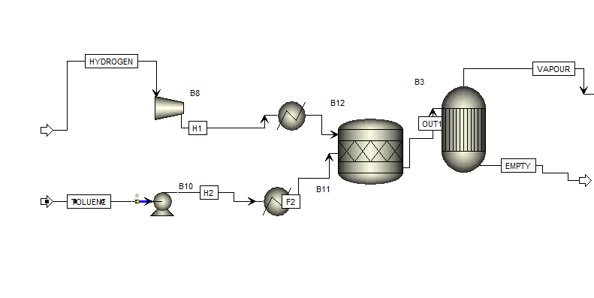
a)

Scale factor for the basis of 20 moles of Toluene and 100 moles of Hydrogen mixture:
1.42358

For this part, assuming 100% recovery of Benzene the stream coming out of Requil is assumed to have flow rate of 265 mol / s

Work required for compressing the hydrogen feed stream=41192.3814 kW(from the results table directly)

Energy required to heat the hydrogen stream fed to reactor = -3596.30830(from the results table directly)

Energy required to heat the toluene stream fed to reactor = 61406.53495 kW

Total energy removed or added to the two reactors to maintain isothermal conditions = -13697.64989 -129.97839 = -13697.64989 + 129.97839 = -13567.6715 kW

b)

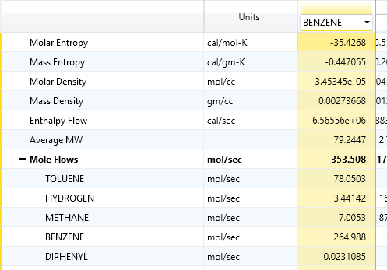

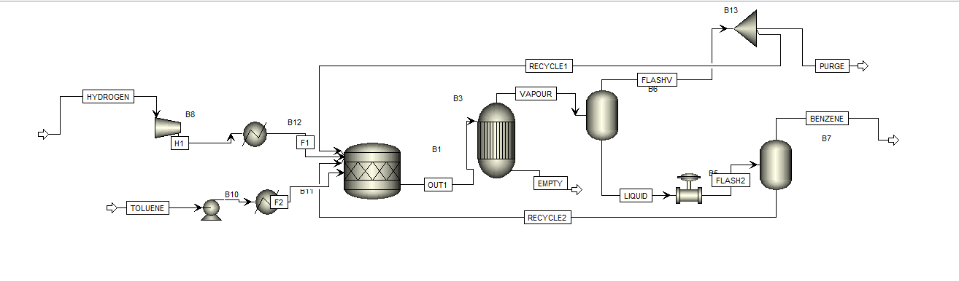
Composition of the vapour stream from the second flash :
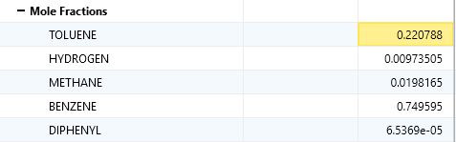

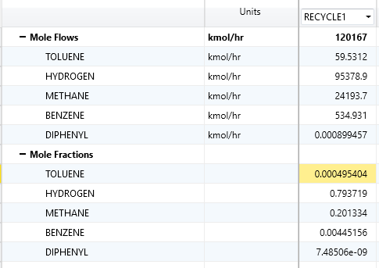

Toluene fresh-feed flow rate = 351.787 mol/sec

Flow rate of recylcle 1 = 120167.030731361 mol/s

Flow rate of recycle 2=184.733892881357 mol/s

amount of energy added/removed to the flash units

Flash 1:-814790.2046796kW

Flash 2:13844.557753308001 kW

c) LOL

